Alpha Particle Detector
This projects demonstrates how to use a relatively inexpensive PIN photodiode, a low voltage op amp and a microcontoller running CircuitPython as an alpha particle detector. This project is inspired by the BFYIII paper Alpha Particle Spectroscopy and Energy Loss, by Rob Knobel, Bei Cai, Sean Musclow, and Will Thompson. I made no attempt to make a signal suitable for energy spectroscopy. There are actually many papers published on using PIN photodiodes as radiation detectors for both energy spectroscopy and counting.
Knobel et al. found that a Hamamatsu S1223-01 PIN photodiode works well. It has an active area of 10 mm², and an unbiased capacitance of 20 pF and costs about $10. Alpha particles cannot penetrate the glass window of the photodiode, so the window of the diode has to be removed.
A convenient source for alpha particles is a ²⁴¹Am source from a smoke detector. The ²⁴¹Am emits alpha particles with 5.486 MeV (85% of the time).
A rough estimate of the signal can be made: About 100 % of the alpha energy is deposited in the photodiode creating electron-hole pairs of energy about 3.5 eV. That is about 1.6 x 10⁶ pairs or about 2.5 x 10⁻¹³ C. The 20 pF photodiode capacitance discharged through a 10 MΩ resistor give a time constant of 4 x 10⁻⁴ s and thus a voltage of V_{α} = 13 mV. This is a feasible signal to work with.
The challenge for this project is to design a circuit for the alpha particle signal that will trigger the microprocessor and work on on the single sided 3.3 V working voltage of the microcontoller.

Lego Spacers

Building the Blocks
In Lego terminology a plate is a piece 1/3rd the height of a block. Legos can be sanded to get a smooth surface.
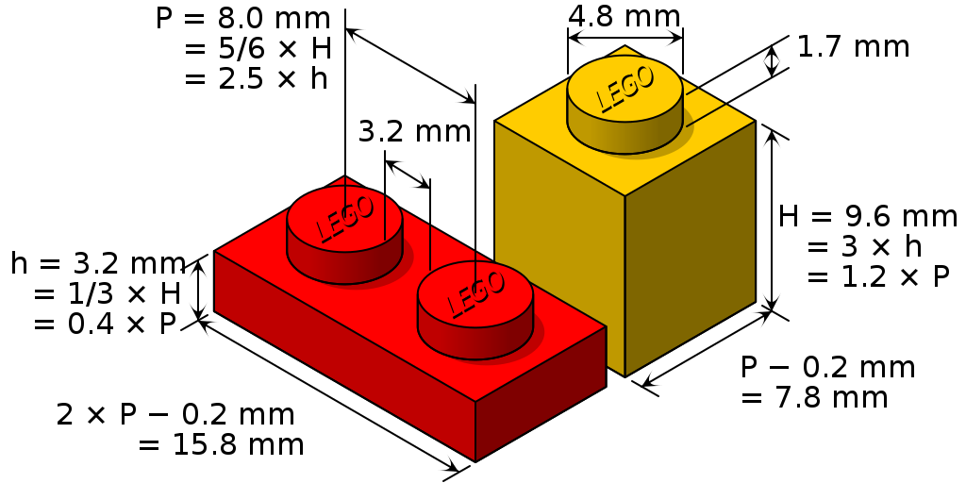Figure 1: Official dimensions of Lego pieces.
- Use genuine Lego pieces. The dimensions are very tightly controlled.
- I recommend using a gel superglue to glue Lego to the case and to each other. The gel superglue gives you time to get the pieces in place and it stays in place when gluing pieces vertically.
- Figure X. Glue a 2x8 Lego block to the case bottom. It should be centered with one end just touching the inside wall of the case.
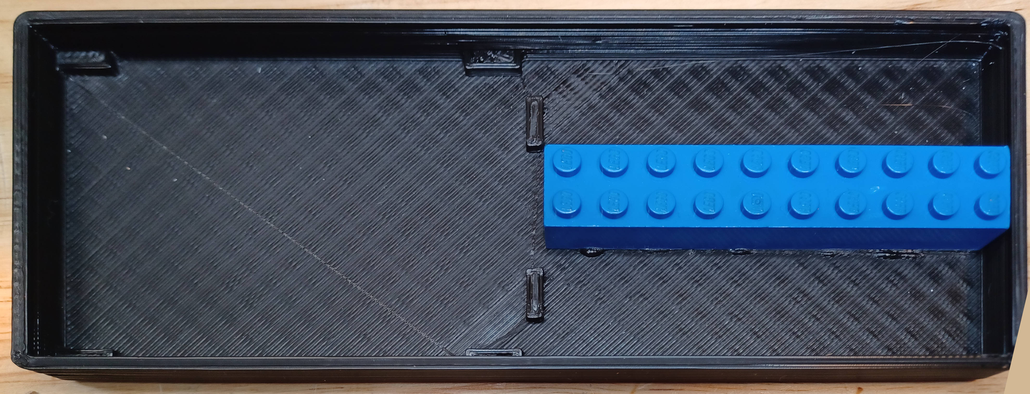Figure 2: Glue the 2x8 black to the bottom of the case. The breadboard will be mounted on the left.
- Figure X. Snap the 2x4 top block (red in the figure above) to two 2x4 blocks as a jig and stand it on end. Glue a 1x2 plate to the side of the block with a gap of about 1 mm.
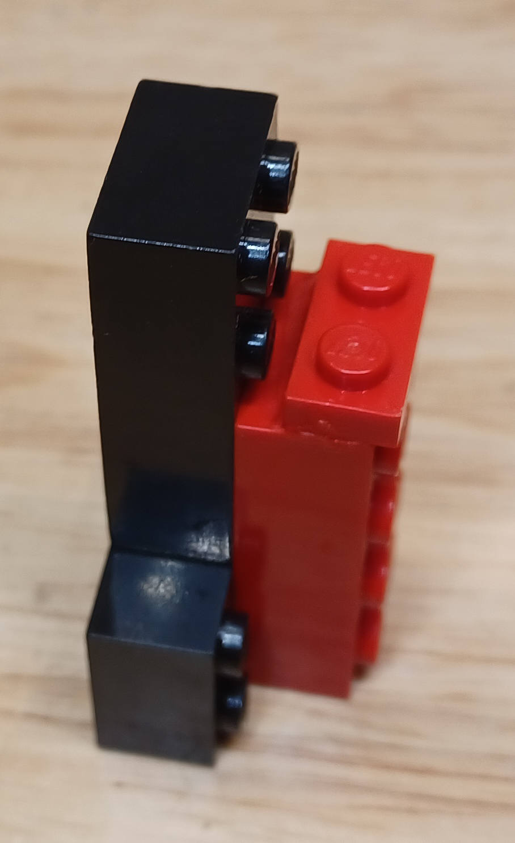Figure 3: Glue a 1x2 plate to the side of a 2x4 block. Here it is standing on end to help gluing.
- Glue an alpha source to a 1x2 cap. It is a 1x2 plate without pegs on the top. Caps are hard to find; you can cut the pegs off of a 1x2 plate instead and sand it to make it flat.
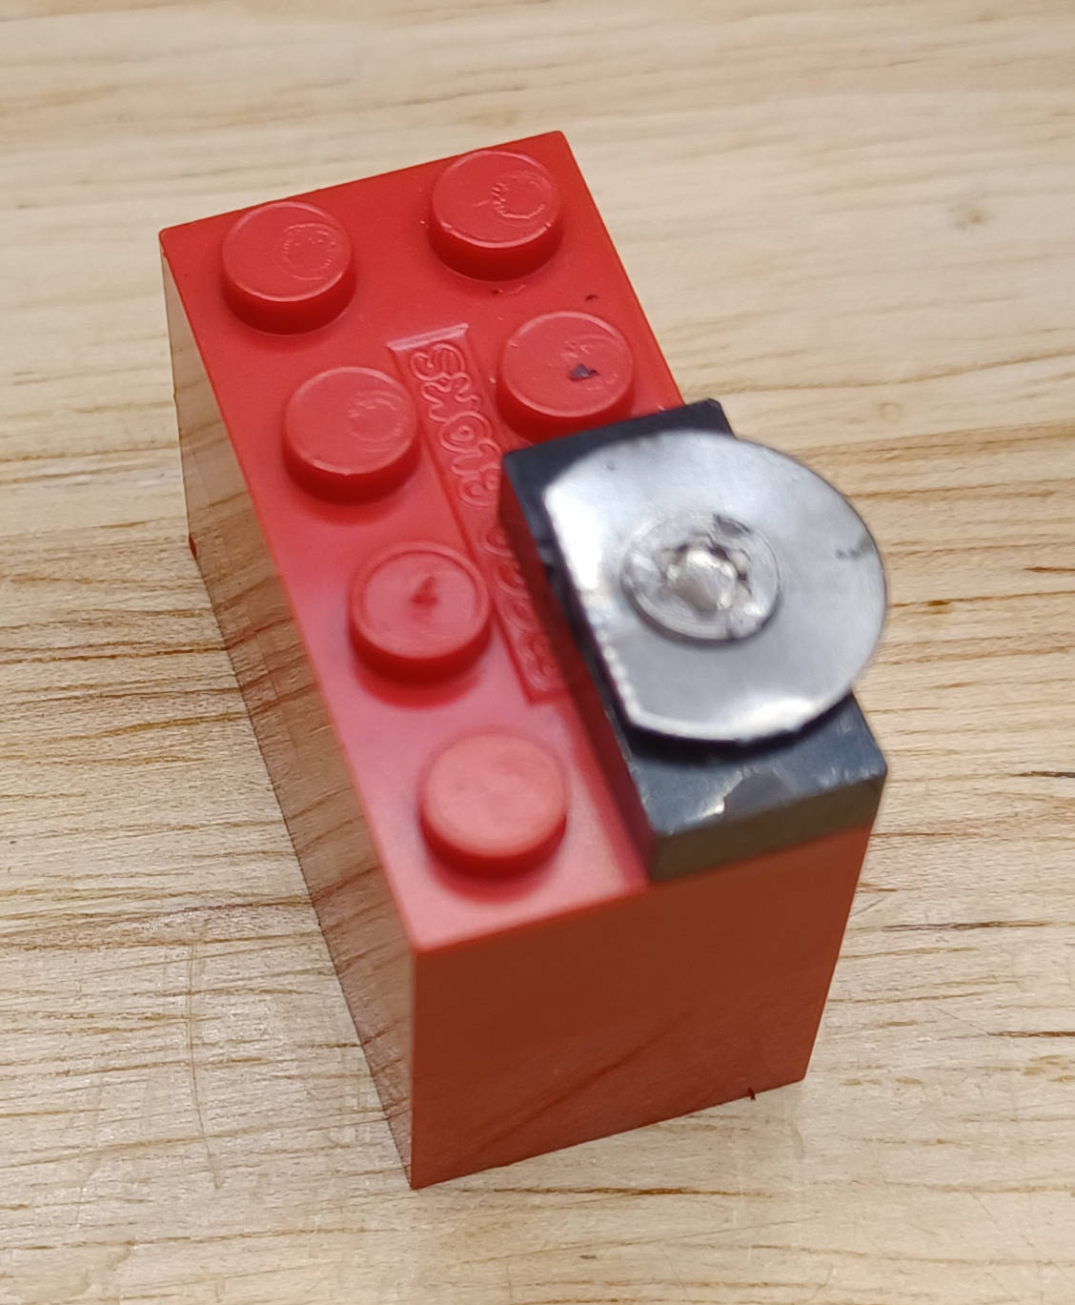Figure 4: Glue the alpha source on a 1x2 cap. Here the cap is snapped to a block to hold it while gluing.
- In addition to these pieces, you need two 1x2 plates and one 1x2 block.

Using the Lego
The horizontal Lego base has a pitch of 8 mm between pegs. By gluing a Lego plate at right angles to the base, there is an additional pitch of 3.2 mm. By combining these two you can move the alpha source in increments of 1.6 mm. Figure X below shows one way of arranging the Lego to get increments of 1.6 mm out to 35.2 mm plus one additional increment of 3.2 mm. The red, yellow and blue pieces are blocks; the rest are plates.
The terminology 1,2, for example, means the 2x4 block is 1 peg to the right, and 2 plates are snapped on horizontally. 3 plates equal 1 block, so to make a 4 use one plate and one block.
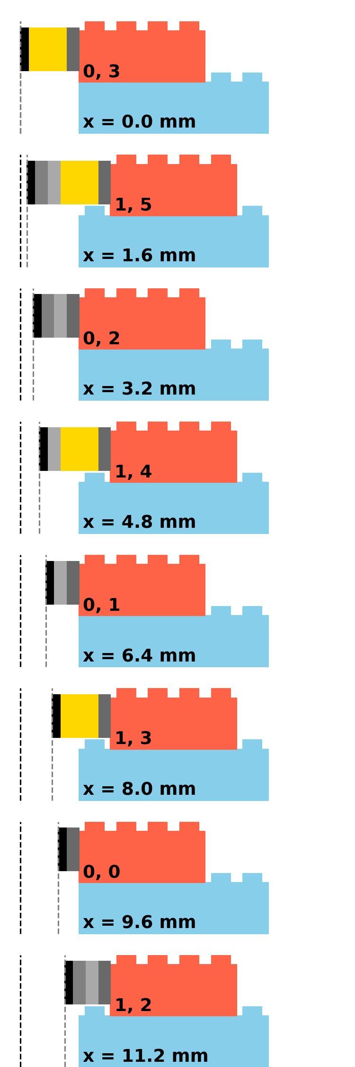  T | 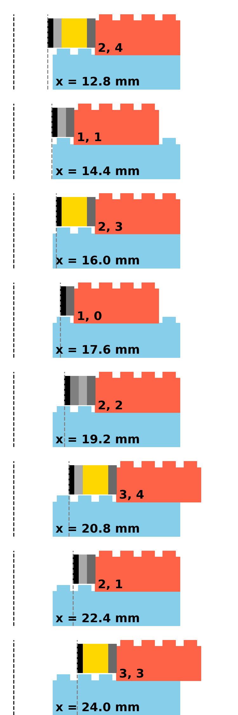Figure 5: Snapping together Lego pieces to take alpha counts versus distance. | 